Clustering Analysis Report
Stage 2 Deliverables

Jenita Niroshini Jesuraj Ramanan -
Data Analyst- Clustering Analysis

1. Introduction

The purpose of this clustering analysis was to find distinct customer segments within the customer churn dataset utilising the K-Means clustering algorithm. The analysis targeted to group customers with same characteristics and subsequently test how churn behaviour varies across the identified customer segments.
The dataset used for clustering was provided following the data preparation stage. The final scaled dataset had 6,741 customer records and 11 variables. The clustering analysis was conducted in Python using Google Colab, with Pandas and NumPy for data handling, Matplotlib for visualisation, and Scikit-learn for K-Means clustering, silhouette analysis and PCA.

2. Dataset Preparation for Clustering

The scaled dataset contained the following variables: gender, SeniorCitizen, Dependents, tenure, Phone Service, Multiple Lines, Internet Service, Monthly Charges, Churn, Contract One year and Contract Two year.
Before clustering, the dataset was validated to confirm its suitability for analysis. All clustering features were numeric and no missing values were identified.
The Churn variable was excluded from the features used to train the K-Means model. This allowed the algorithm to identify customer segments based on customer characteristics independently of the known churn outcome. After excluding Churn, 10 features were used for clustering. As the dataset had already been scaled during the data-preparation stage, additional scaling was not applied during this clustering stage.

3. Optimal Number of Clusters

3.1 Elbow Method
The Elbow Method was used as the main technique for selecting an appropriate number of customer clusters. K-Means models were evaluated for K values from 2 to 10, and inertia (within-cluster sum of squares) was recorded for each model.
Number of Clusters (K) | Inertia / WCSS
2 | 17,918.02
3 | 14,634.40
4 | 12,956.38
5 | 12,291.47
6 | 11,757.57
7 | 11,312.20
8 | 10,942.18
9 | 10,643.53
10 | 10,418.41

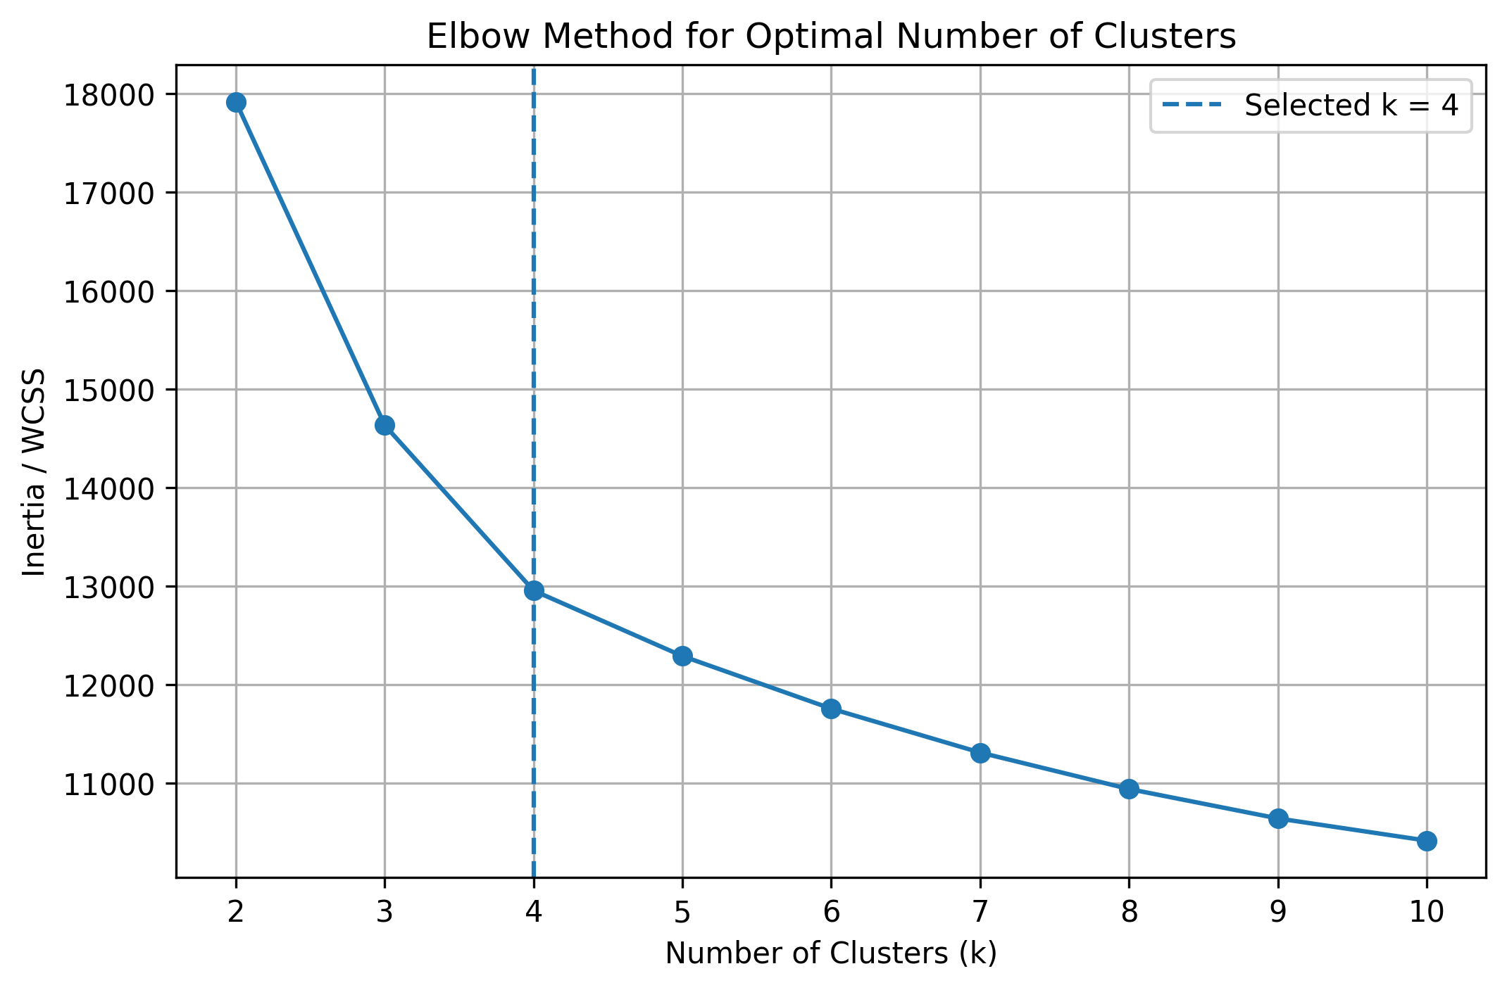
The Elbow Method reflected a substantial reduction in inertia up to approximately K=4, after which the improvement became more gradual. Therefore, K=4 was selected as a useful four-segment solution for the final customer segmentation.
Supporting visualisation: elbow_method.png

3.2 Silhouette Analysis
Silhouette analysis was used as an additional diagnostic to assess cluster separation. A higher silhouette score generally indicates stronger separation between clusters.
K | Silhouette Score
2 | 0.2233
3 | 0.2134
4 | 0.1998
5 | 0.1763
6 | 0.1527
7 | 0.1403
8 | 0.1367
9 | 0.1368
10 | 0.1308

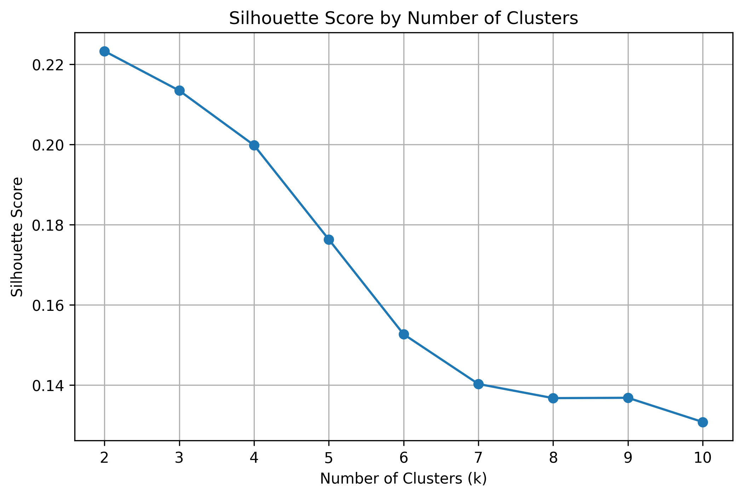

The highest silhouette score was obtained at K=2 (0.2233), while K=4 produced a score of 0.1998. The silhouette analysis therefore did not independently identify K=4 as the highest-scoring solution. Considering the Elbow Method together with the project objective of obtaining more detailed and interpretable customer segments, four clusters were selected for the final K-Means analysis.
Supporting visualisation: silhouette_scores.png

4. K-Means Model Training
The final K-Means model was trained using four clusters, random_state=42 and n_init=10. The model used the 10 scaled customer characteristics as input features. A fixed random state was used to support reproducibility.
Following model training, each of the 6,741 customer records was assigned to Cluster 0, Cluster 1, Cluster 2 or Cluster 3.
Trained model file: kmeans_customer_churn_model.pkl
Training code/notebook: Customer_Churn_Clustering_Analysis.ipynb

5. Cluster Distribution

Cluster | Number of Customers | Percentage
Cluster 0 | 1,586 | 23.53%
Cluster 1 | 1,882 | 27.92%
Cluster 2 | 1,123 | 16.66%
Cluster 3 | 2,150 | 31.89%
Total | 6,741 | 100%

Cluster 3 was the largest segment, representing 31.89% of the dataset, while Cluster 2 was the smallest at 16.66%.

6. Cluster Profiling and Labelling

Cluster profiles were generated by calculating the average feature values for customers within each cluster. Tenure and MonthlyCharges were particularly useful for interpretation. Because these variables were scaled during preprocessing, the values represent positions relative to the overall dataset rather than literal months or dollar amounts.
Cluster | Avg. Scaled Tenure | Avg. Scaled Monthly Charges | Descriptive Label
Cluster 0 | -0.89 | -1.08 | Shorter-Tenure, Lower-Charge Customers
Cluster 1 | 1.06 | 0.92 | Longer-Tenure, Higher-Charge Customers
Cluster 2 | 0.88 | -1.04 | Longer-Tenure, Lower-Charge Customers
Cluster 3 | -0.73 | 0.53 | Shorter-Tenure, Higher-Charge Customers

These descriptive labels were created to assist interpretation and do not replace the original K-Means cluster identifiers.

7. Churn Analysis by Customer Segment

The Churn variable was not used to create the clusters. After clustering was completed, churn was compared across the four independently identified customer segments.
Cluster | Customers | Churned Customers | Observed Churn Rate
Cluster 0 | 1,586 | 395 | 24.91%
Cluster 1 | 1,882 | 294 | 15.62%
Cluster 2 | 1,123 | 54 | 4.81%
Cluster 3 | 2,150 | 1,048 | 48.74%

Cluster 3 recorded the highest observed churn rate at 48.74% and was characterised by relatively shorter tenure and higher monthly charges. Cluster 2 recorded the lowest observed churn rate at 4.81% and was characterised by relatively longer tenure and lower monthly charges.
These findings indicate an association between the identified customer segments and churn behaviour. The clustering analysis does not establish that tenure, monthly charges or other characteristics directly cause churn.

8. Cluster Visualisation Using PCA

Because the K-Means model was trained using 10 customer features, Principal Component Analysis (PCA) was applied to reduce the data to two principal components for visualisation.
The resulting PCA scatter plot displays the four customer clusters using separate cluster labels. The clusters occupy different areas of the reduced two-dimensional feature space, although some proximity and overlap can be observed around cluster boundaries.
PCA was used for visualisation purposes only. The K-Means model itself was trained using the full set of 10 clustering features.
Supporting visualisation: kmeans_clusters_pca.png

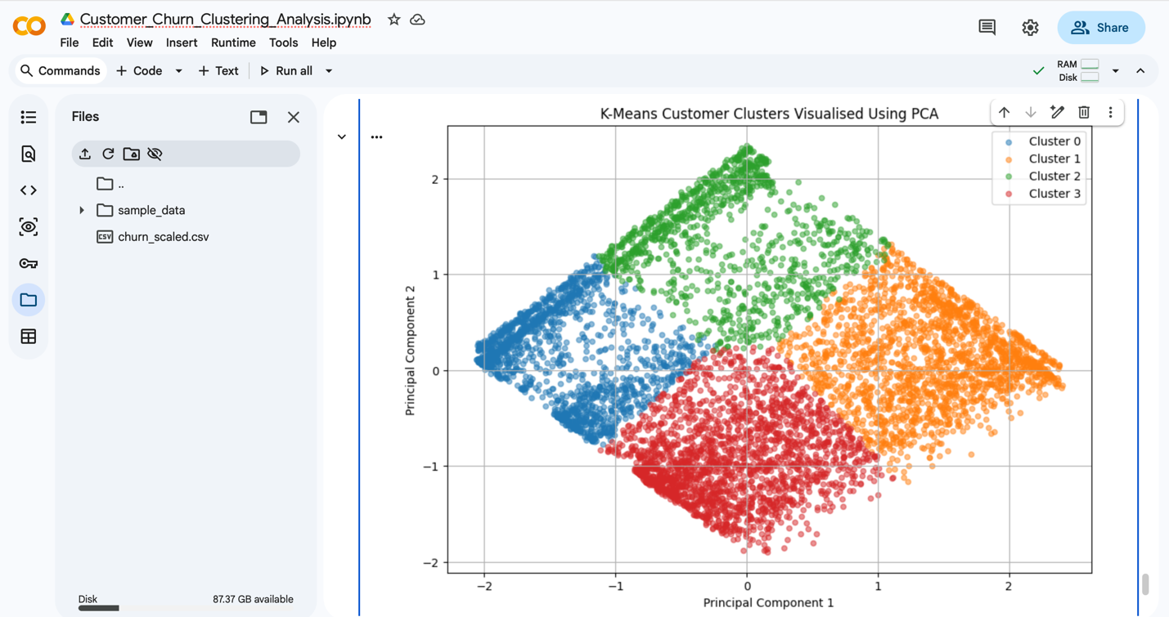

9. Key Findings and Insights

· Four customer segments were identified using K-Means clustering.
· Cluster 3 was the largest segment, containing 2,150 customers (31.89%).
· Observed churn varied substantially across the segments: Cluster 3 had the highest churn rate at 48.74%, while Cluster 2 had the lowest at 4.81%.
· Cluster 3 combined relatively shorter tenure with higher monthly charges, while Cluster 2 combined relatively longer tenure with lower monthly charges.
· The segmentation provides a useful foundation for subsequent churn prediction, reporting and customer-retention analysis.

10. Conclusion

K-Means clustering was successfully applied to the prepared customer dataset to identify meaningful customer segments. The Elbow Method was used as the primary basis for selecting K=4, with silhouette analysis used as an additional diagnostic.
The final model segmented 6,741 customers into four groups. Cluster profiling, churn comparison and PCA visualisation were then used to interpret the segments. The analysis identified substantial variation in observed churn rates between clusters, providing a foundation for the next stages of customer churn prediction and reporting.

11. Clustering Analysis Deliverables

Deliverable Requirement | Files / Evidence
Optimal Number of Clusters | elbow_method.png; silhouette_scores.png; Sections 3.1–3.2 of this report
Trained K-Means Model | kmeans_customer_churn_model.pkl; Customer_Churn_Clustering_Analysis.ipynb
Visualisation and Labelling of Clusters | kmeans_clusters_pca.png; cluster_profiles.csv; cluster_summary.csv; customer_clusters.csv; Sections 5–8 of this report

